DEVELOP THE WEB APPLICATION USING NODE-RED
TEAM MEMBERS | Abiyavincy D, Berlin K, Jemilda J, Kerin Shinu VS
PROJECT NAME | Real-Time River Water Quality Monitoring and Control System

1.Double-click the tab with the flow name, and call it Earthquake Details.

2.Click the hamburger menu, and then click Manage palette. Look for node-rednode- open weather map to install these additional nodes in your palette.

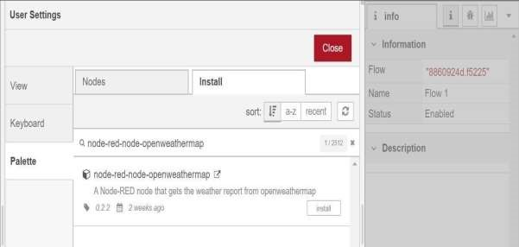

Add an HTTP input node to your flow.

Double-click the node to edit it. Set the method to GET and set the URL to /earthquakeinfo-hr.

1.Add an HTTP response node, and connect it to the previously added HTTP input node. All other nodes introduced in this sub-section is to be added between the HTTP input node and the HTTP response node.

2.Add an HTTP request node and set the URL to

https://earthquake.usgs.gov/earthquakes/feed/v1.0/summary
/all_hour.geojson, the Method to GET and the Return to a parsed JSON object. This will allow extracting all earthquakes that occurred within the last hour. Name this node Get.

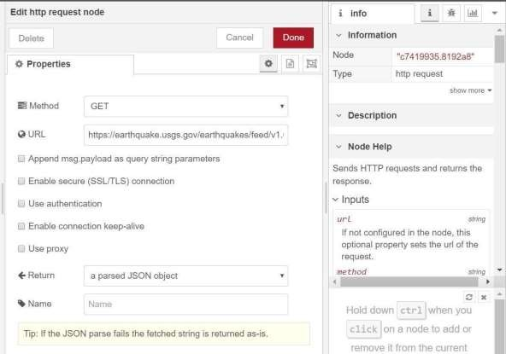

Add a change node. Double-click the node to modify it. Name this node Set Earthquake Info. In the Rules section, add rul to Delete msg.topic, es msg.headers, msg.statusCode, msg.responseUrl and msg.redirectList

"type":properties.type,
"magnitude": properties.mag,
"location": properties.place,
"longitude":geometry.coordinates[0],
"latitude":geometry.coordinates[1],
"depth":geometry.coordinates[2],
"timestamp": $fromMillis( properties.time

